Requirements Analysis
Requirement analysis is significant and essential activity after elicitation. We analyze, refine, and scrutinize the gathered requirements to make consistent and unambiguous requirements. This activity reviews all requirements and may provide a graphical view of the entire system. After the completion of the analysis, it is expected that the understandability of the project may improve significantly. Here, we may also use the interaction with the customer to clarify points of confusion and to understand which requirements are more important than others.
The various steps of requirement analysis are shown in fig:
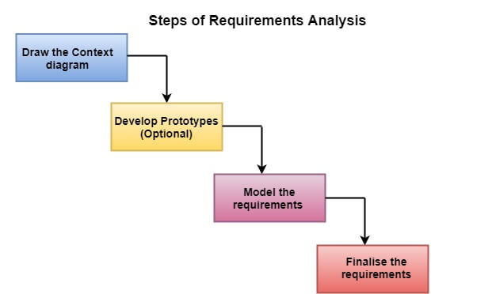
(i) Draw the context diagram: The context diagram is a simple model that defines the boundaries and interfaces of the proposed systems with the external world. It identifies the entities outside the proposed system that interact with the system. The context diagram of student result management system is given below:
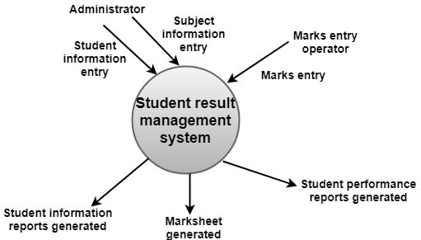
(ii) Development of a Prototype (optional): One effective way to find out what the customer wants is to construct a prototype, something that looks and preferably acts as part of the system they say they want.
We can use their feedback to modify the prototype until the customer is satisfied continuously. Hence, the prototype helps the client to visualize the proposed system and increase the understanding of the requirements. When developers and users are not sure about some of the elements, a prototype may help both the parties to take a final decision.
Some projects are developed for the general market. In such cases, the prototype should be shown to some representative sample of the population of potential purchasers. Even though a person who tries out a prototype may not buy the final system, but their feedback may allow us to make the product more attractive to others.
The prototype should be built quickly and at a relatively low cost. Hence it will always have limitations and would not be acceptable in the final system. This is an optional activity.
(iii) Model the requirements: This process usually consists of various graphical representations of the functions, data entities, external entities, and the relationships between them. The graphical view may help to find incorrect, inconsistent, missing, and superfluous requirements. Such models include the Data Flow diagram, Entity-Relationship diagram, Data Dictionaries, State-transition diagrams, etc.
(iv) Finalise the requirements: After modeling the requirements, we will have a better understanding of the system behavior. The inconsistencies and ambiguities have been identified and corrected. The flow of data amongst various modules has been analyzed. Elicitation and analyze activities have provided better insight into the system. Now we finalize the analyzed requirements, and the next step is to document these requirements in a prescribed format.

